SYDNEY WESTERN CITY PLANNING PANEL ASSESSMENT REPORT

Panel Number: | PPSSWC-371
Application Number: | 2023/556/1.
Local Government Area: | Camden.
Development: | Staged construction of two six-storey commercial buildings and their use as an office premises comprising three levels of basement car parking and associated site works.
Capital Investment Value: | $93,581,005
Site Address(es): | 62 Central Avenue, Oran Park
Applicant: | Greenfields Development Company No.2 Pty Ltd
Owner(s): | Perich Property Trust
Date of Lodgement: | 10 October 2023.
Number of Submissions: | Nil.
Number of Unique Objections: | Nil.
Classification: | Regionally significant.
Recommendation: | Approve with conditions.
Regionally Significant Development Criteria (Schedule 6 of State Environmental Planning Policy (Planning Systems) 2021): | General development capital investment value >$30 million.
List of All Relevant Section 4.15(1)(a) Matters: | - State Environmental Planning Policy (Planning Systems) 2021.  - State Environmental Planning Policy (Precincts - Western Parkland City) 2021.  - State Environmental Planning Policy (Transport and Infrastructure) 2021.  - State Environmental Planning Policy (Resilience and Hazards) 2021.  - State Environmental Planning Policy (Biodiversity and Conservation) 2021.  - Camden Development Control Plan 2019.  - Oran Park Development Control Plan (as amended)
List all Documents Submitted with this Report for the Panel’s Consideration: | - Assessment report.  - State Environmental Planning Policy (Precincts - Western Parkland City) 2021 assessment table.  - Oran Park Development Control Plan (as amended) assessment table.  - Camden Development Control Plan 2019 assessment table.  - Applicant’s Clause 4.6 written request seeking to justify the contravention of a development standard.  - Recommended conditions.  - Proposed plans.
Development Standard Contravention Request(s): | - Section 4.3 – Height of Buildings - State Environmental Planning Policy (Precincts - Western Parkland City) 2021.
Summary of Key Submission Issues: | No issues raised.
Report Prepared By: | Lachlan Hutton (Senior Town Planner)
Report Date: | March 2024.

Summary of Section 4.15 Matters

Yes
Have all recommendations in relation to relevant Section 4.15 matters been summarised in the Executive Summary of the assessment report?

Legislative Sections Requiring Consent Authority Satisfaction

Yes
Have relevant sections in all applicable environmental planning instruments where the consent authority must be satisfied about a particular matter been listed and relevant recommendations summarised in the Executive Summary of the assessment report?

Development Standard Contraventions

 | Yes | N/A
If a written request for a contravention to a development standard has been received, has it been attached to the assessment report?

Special Infrastructure Contributions

 | Yes | No
Does the application require Special Infrastructure Contributions?

Conditions

Yes
Have draft conditions been provided to the applicant for comment?

Purpose of Report

The purpose of this report is to seek the Sydney Western City Planning Panel’s (the Panel’s) determination of a development application (DA) for the staged construction of two six-storey commercial buildings comprising three levels of basement car parking and associated site works at 62 Central Avenue, Oran Park.

The Panel is the consent authority for this DA as the capital investment value (CIV) of the development is $93,581,005. This exceeds the CIV threshold of $30 million for Council to determine the DA pursuant to Schedule 7 of State Environmental Planning Policy (Planning Systems) 2021.

Summary of Recommendation

That the Panel determine DA/2023/556/1 for the staged construction of two six-storey commercial buildings and their use as an office premises comprising three levels of basement car parking and associated site works pursuant to Section 4.16 of the Environmental Planning and Assessment Act, 1979 by granting consent subject to the conditions attached to this report.

Executive Summary

Council is in receipt of a DA for the staged construction of two six-storey commercial buildings and their use as an office premises comprising three levels of basement car parking and associated site works at 62 Central Avenue, Oran Park.
The DA has been assessed against the Environmental Planning and Assessment Act 1979, the Environmental Planning and Assessment Regulation, 2021, relevant environmental planning instruments, development control plans and policies.

A summary of the assessment of all relevant environmental planning instruments is provided below with a detailed assessment provided later in the report.

State Environmental Planning Policy (Planning Systems) 2021. | The Panel is the consent authority for this DA as the development has a CIV of $93,581,005. The CIV threshold for Council to determine the DA is $30 million.
State Environmental Planning Policy (Precincts - Western Parkland City) 2021 (Western Parkland City SEPP). | The development is permitted with consent in the B2 Local Centre zone. It is consistent with the zone objectives and is generally compliant with the matters for consideration, with the exception to section 4.3 pertaining to height of buildings.
State Environmental Planning Policy (Transport and Infrastructure) 2021 (Transport and Infrastructure SEPP). | The DA was referred to Endeavour Energy and Transport for NSW for comment pursuant to the Transport and Infrastructure SEPP. Comments received have been considered.
State Environmental Planning Policy (Resilience and Hazards) 2021 (Resilience and Hazards SEPP). | Council staff have considered the history of the site and note that the site has previously been signed off by a site auditor confirming that the land is suitable for the proposed land use. Council staff are satisfied that the site is suitable for the proposed development.
State Environmental Planning Policy (Biodiversity and Conservation) 2021 (Biodiversity and Conservation SEPP). | The development is considered satisfactory in terms of the matters for consideration in Chapter 6 of the Biodiversity and Conservation SEPP.

The applicant seeks a contravention to the height of buildings development standard that applies to the site. The development standard limits buildings to a maximum height of 24m. Both commercial buildings will exceed this standard, with Commercial Building 4 being the highest at 29.36m above existing ground level (contravention of 5.36m or 22%). The contraventions are assessed in detail in this report and are supported by Council staff.

The DA was publicly exhibited for a period of 14 days in accordance with Camden Community Participation Plan 2021. The exhibition period was from 19 October to 2 November 2023 and no submissions were received.

Based on the assessment, it is recommended that the DA be approved subject to the conditions attached to this report.

Key Planning Control Variations

Control | Proposed | Variation
24m Maximum Building Height. | Commercial Building 3 = 29.16m  Commercial Building 4 = 29.36m | 5.16m or 22%  5.36m or 22%

Aerial Photo


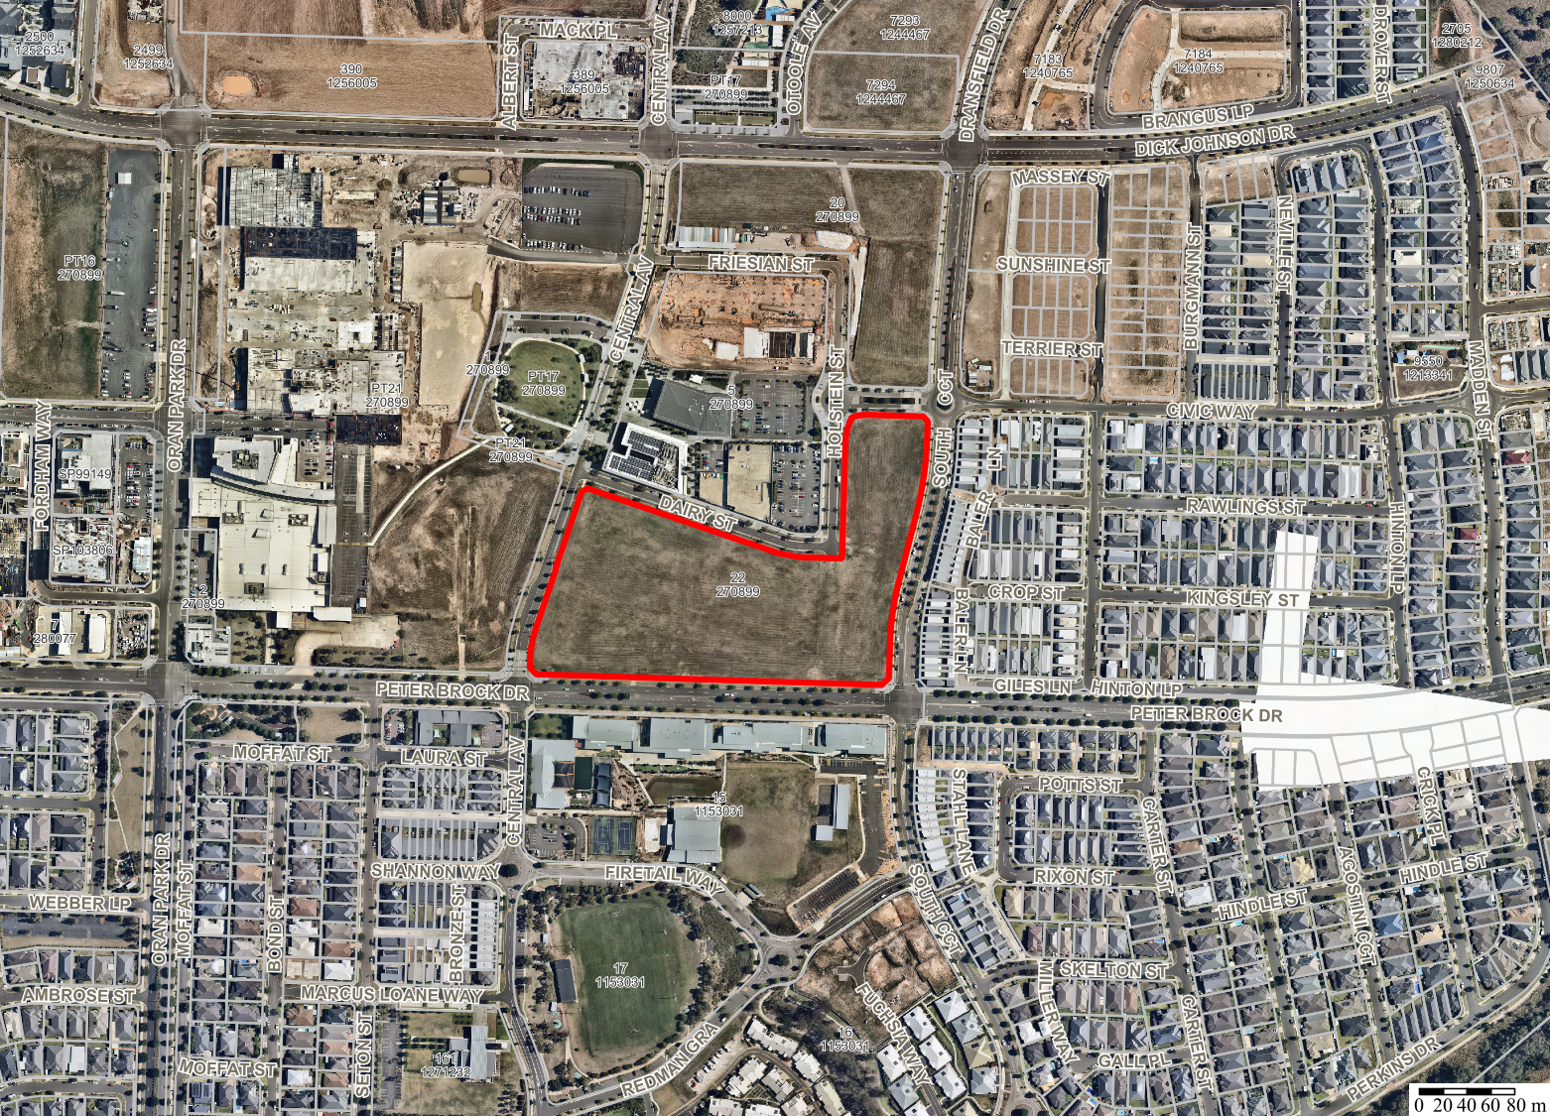
DA/2023/556/1
Aerial

 | Subject Site:  62 Central Avenue ORAN PARK  LOT: 22 DP: 270899

Figure 1: The current lot (outlined red). Yellow outline showing extent of works, blue circle recently approved residential flat buildings (DA/2023/265/1).

The Site

The site is large and irregular in shape, 6,565m² in lot size and is bound by a series of established (and yet to be constructed) roads and is commonly known as 62 Central Avenue, Oran Park (refer fig 1) and is legally described as Lot 22 in Deposited Plan 270899. The site has relative fall toward the south-east of approximately 1.0m.

The site is currently vacant and undeveloped, however, on the north eastern portion of the site development consent (DA/2023/265/1) has been granted for the construction of two x seven storey residential flat buildings (determined by the Sydney Western City Planning Panel in December 2023).

Vehicular access to the site is provided by the private eastern road, which will be constructed under a separate application (DA/2023/631/1). Pedestrian access is available to all elevations, noting that access through the site is achievable from two access points on the southern Peter Brock Drive frontage.

The proposed development which is referred to as Commercial Buildings 3 and 4, is located within the mixed-use precinct along the southern perimeter of the Oran Park Town Centre. The mixed-use precinct is envisaged to support a range of residential, commercial and small-scale retail opportunities; a place where one can live, work, play and shop. The surrounding locality is characterised by existing medium density residential to the east, an educational establishment (Oran Park Anglican College) to the south, the expanding Oran Park Town Podium Shopping Centre to the west and the Council Administration Building to the north.

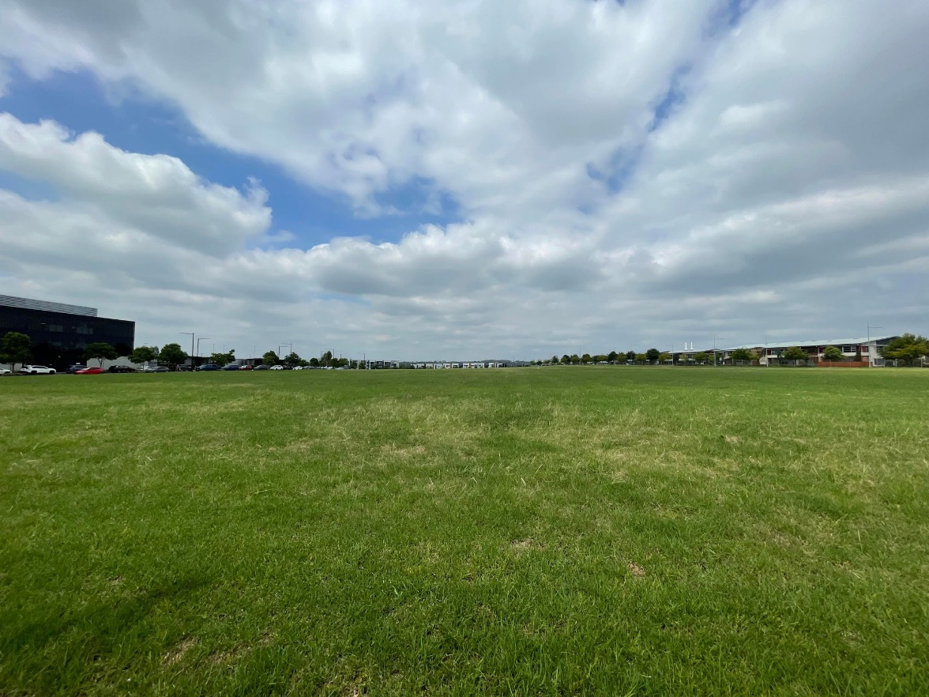
Figure 2: Looking east across the lot from Central Avenue.

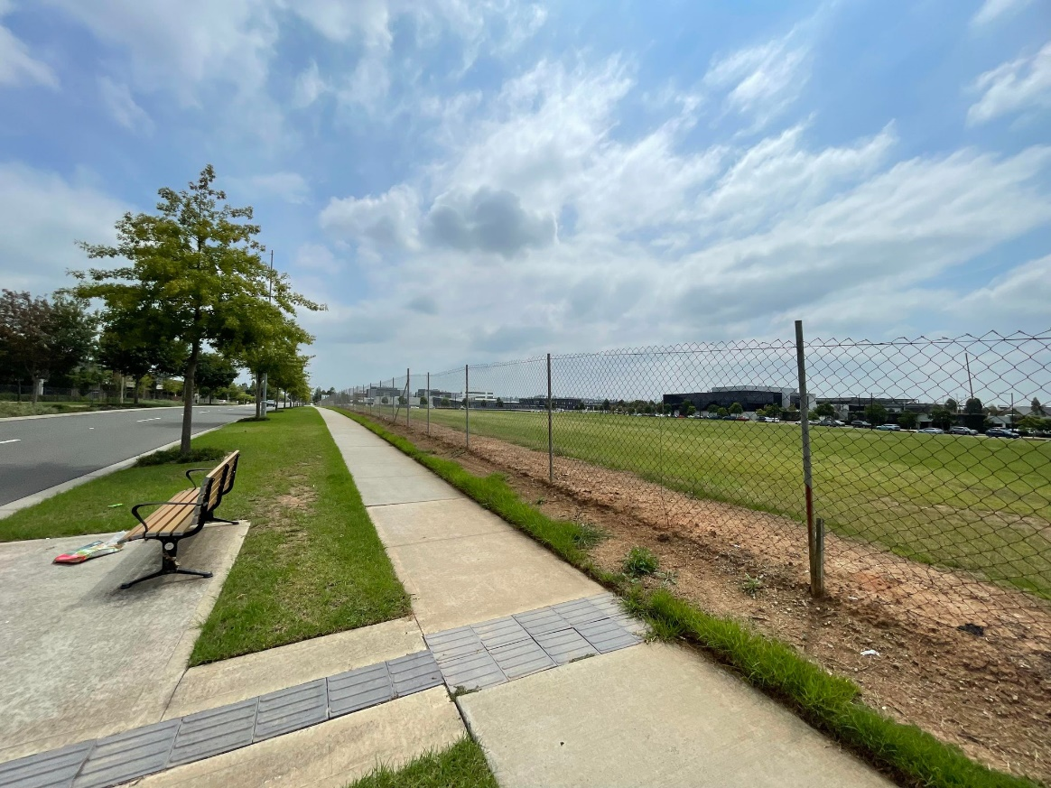
Figure 3: Looking north-west from Peter Brock Drive at approximate location of private road and Commercial Building 4.

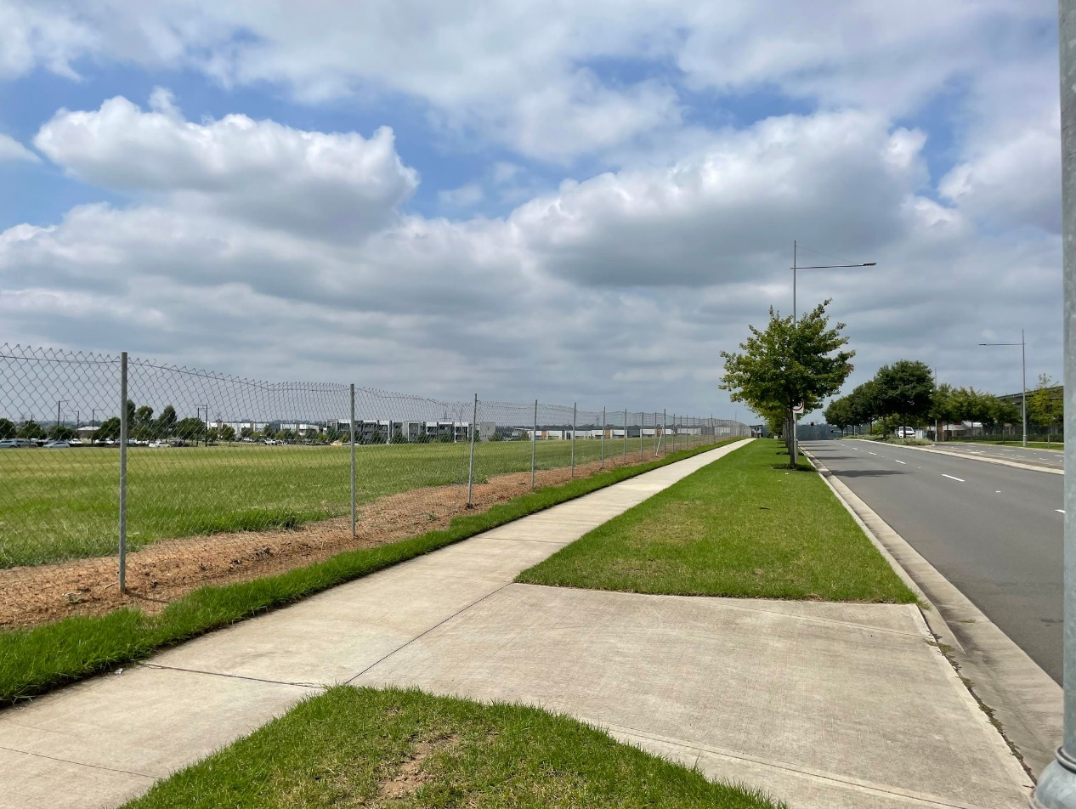
Figure 4: Future corner of Commercial Building 3 looking east along Peter Brock Drive.

Zoning Plan

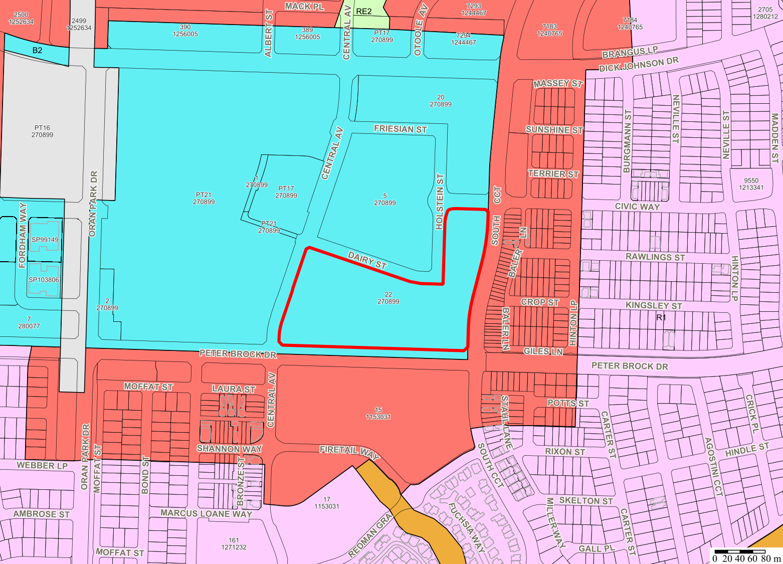
DA/2023/556/1
Aerial

Subject Site:
62 Central Avenue ORAN PARK
LOT: 22 DP: 270899

Figure 5: Zoning map showing the site as being within the B2 Local Centre Zone.

HEIGHT MAP

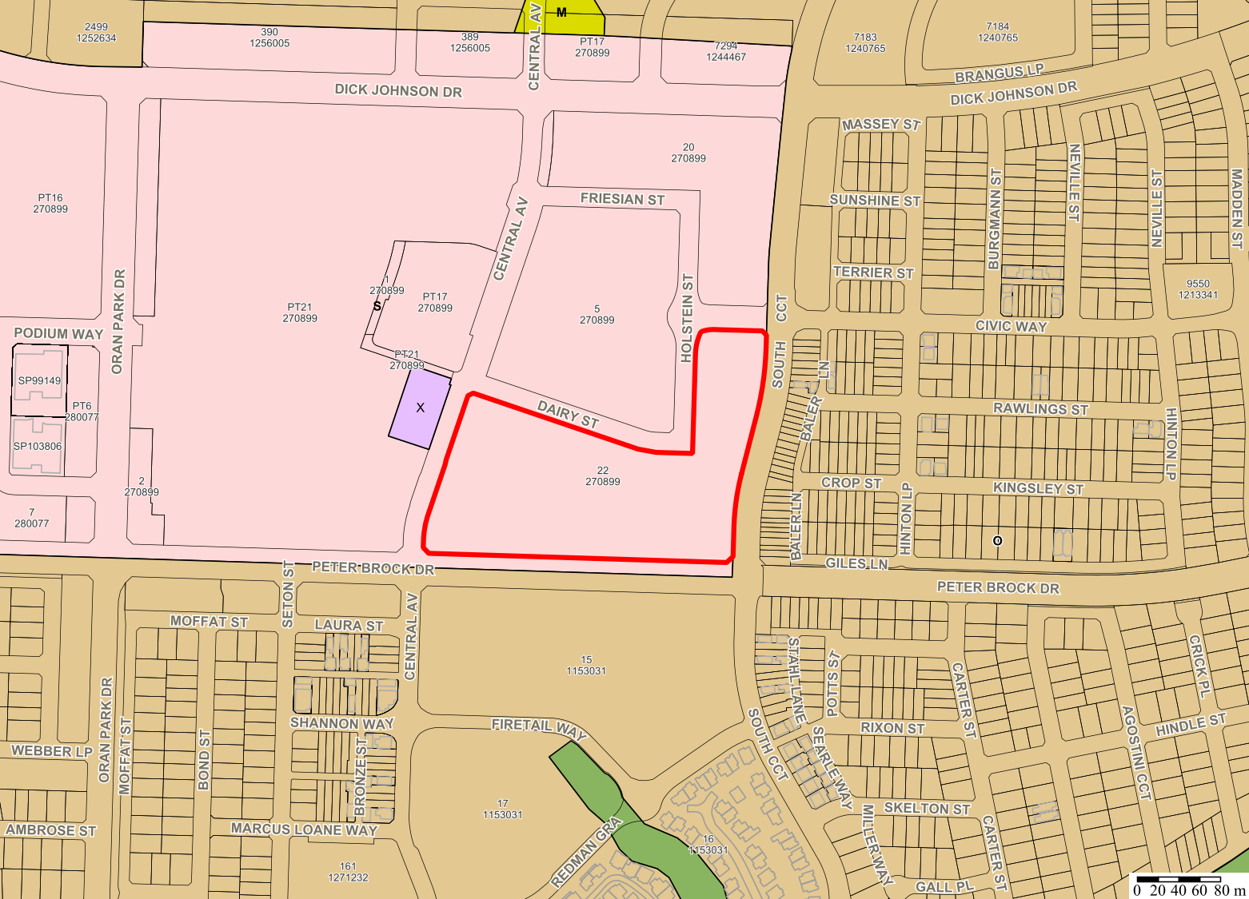
DA/2023/556/1
Aerial

Subject Site:
62 Central Avenue ORAN PARK
LOT: 22 DP: 270899

Figure 6: Height of building map showing the site subject to a maximum height. of 24m.

AREA MASTER PLAN

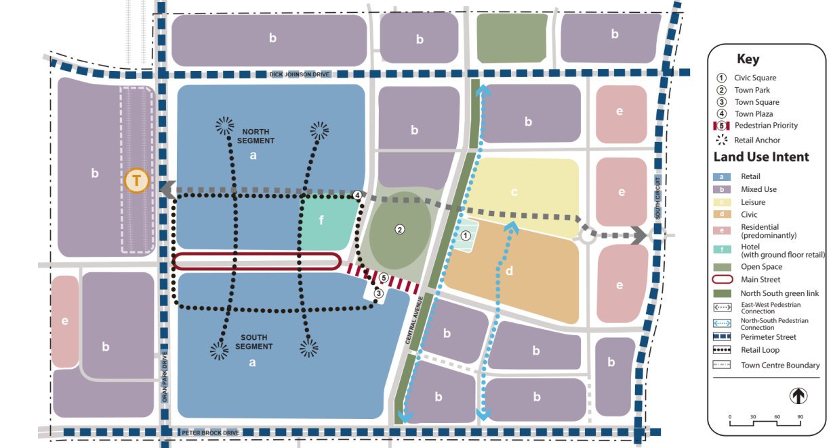
Figure 7: Extract from the Oran Park DCP, showing the site (outlined red) being within the mix-use area.

HISTORY

The relevant development history of the site is summarised in the following table:

Date | Development
13 December 2023. | Approval of DA/2023/265/1 for the construction of two x seven storey residential flat buildings.
28 February 2024. | Approval of DA/2023/631/1 for a Community Title Subdivision to create six lots, roads, landscaping and associated site works.

THE PROPOSAL

DA/2023/556/1 seeks approval for the staged construction of two x six storey commercial buildings.

Specifically, the development involves:

- Construction of two x six storey commercial buildings and use as an office premise.

- Three levels of shared basement car parking and the provision of:

- 556 line-marked spaces (42 of which are nominated as Electric Vehicle spaces).

- 17 motorcycle spaces.

- 26 bicycle spaces.

- Shared loading dock and ancillary areas contained within Commercial Building 4.

- Construction of a private road and associated embellishment to the east of Commercial Building 4.

- Provision for seating, tables, rubbish bins, lighting and planting of private open space areas.

- Upgrade of the existing southern footpath contained to Peter Brock Drive.

- Operating hours of 7am to 9pm, Monday to Sunday.

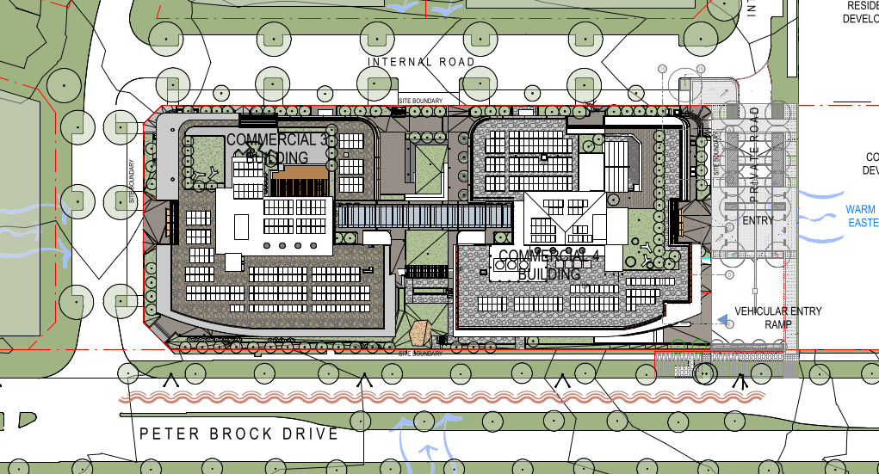
Figure 8: Site plan of the proposed development.

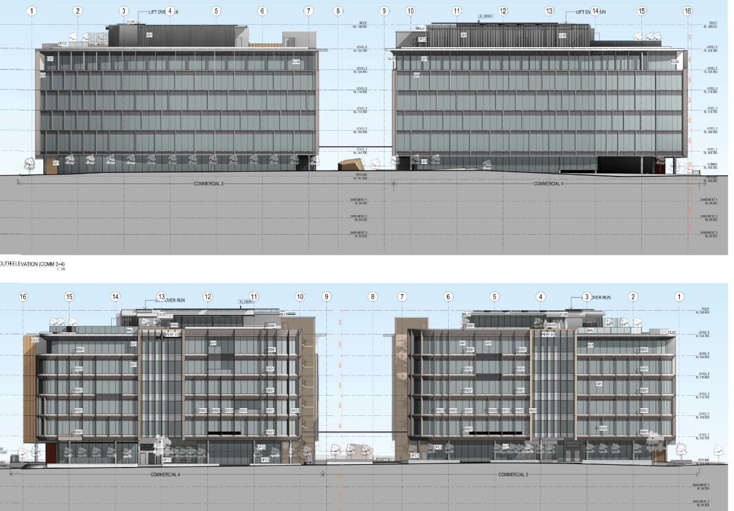
Figure 9: Northern (top) and southern (bottom) elevations of the proposed development.

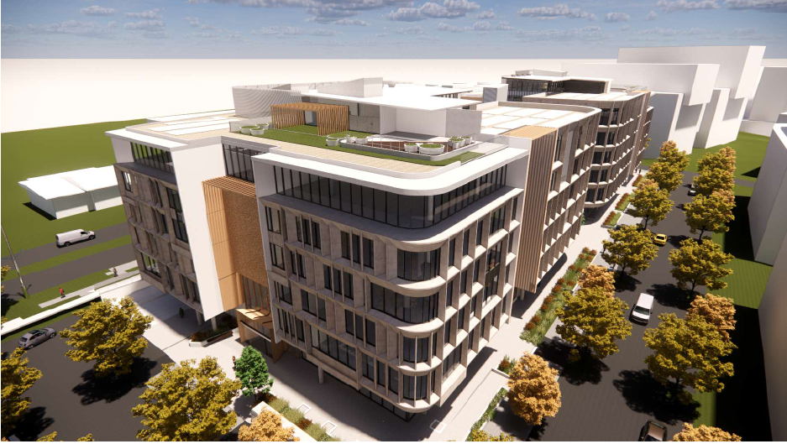
Figure 10: North-western rendered image of the proposed development.

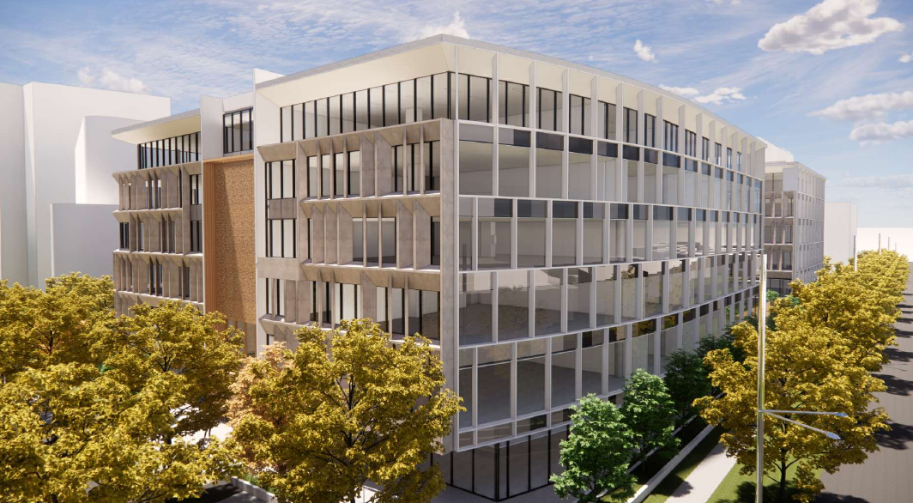
Figure 11: Looking east along Peter Brock Drive from future intersection at Commercial Building 3 – see figure 4.

PANEL BRIEFING

Council staff briefed the DA to the Panel on 13 November 2023. The following discussion provides an assessment of how the issues raised by the Panel at the briefing have been addressed:

- The chair noted that the flythrough indicates that the development includes curved masonry. The chair recommends that such proposed design features, materials and finishes are conditioned to ensure they are retained in the ultimate constructed design of the development.

Officer comment:

Council staff acknowledge the importance of retaining the proposed design features, materials and finishes. As such, Council staff have imposed a condition of consent requiring colours, finishes and materials to be provided in accordance with the approved plans.

- The chair recommended for incorporation of ecologically sustainable measures including solar power and electric vehicle charging facilities.

Officer comment:

The development provides a variety of ecologically sustainable measures, specifically:

- Increased provision of solar panels to the roof of Commercial Building 3 and 4;
- Provision of 42 electric vehicle parking spaces;
- Rainwater harvesting for reuse on site; and
- Incorporation of vertical and horizontal sun shades.

- The panel enquired as to whether solar access analysis has been undertaken for the open space between the proposed buildings.

Officer comment:

Council staff confirm that solar access analysis was carried out on the open space between the buildings. Council staff have reviewed the solar access diagrams, with the area receiving direct solar access from 10am to 2pm to at least 50% of its area (approx. 1,199m²) on June 21.

- The chair noted that attention has been given to the activation of the external ground level plane and noted that retaining walls or similar obstructions should be avoided where they may reduce activation.

Officer comment:

Retaining walls and similar obstructions are avoided where practically possible. There is some difficulty in avoiding these altogether due to existing levels onsite. As such, at grade pedestrian access is provided in prominent locations, particularly along the northern elevation, envisaged as the primary entry point to both commercial buildings. Eastern, southern and western elevations incorporate a combination of stairs and pedestrian ramps typical for a development of this scale. Efforts have been made to retain the natural fall in the main outdoor communal area which is located between the two commercial buildings. Hypothetically, pedestrians could travel in a north / south direction between the two buildings without having to navigate steps or retaining walls.

- The chair noted the intention for staged construction and recommended that a staging plan be required, possibly by conditions of consent.

Officer comment:

A staging plan has been submitted as part of the development. Stage 1 involves the constructing all three basement levels, Commercial Building 3, the private eastern road, public domain embellishment and site landscaping. Stage 2 will construct Commercial Building 4. A condition of consent is recommended requiring the development to be carried out in accordance with the approved staging plan.

ASSESSMENT

Environmental Planning and Assessment Act 1979 - Section 4.15(1)

In determining a DA, the consent authority is to take into consideration such of the following matters as are of relevance to the development the subject of the DA:

(a)(i) the provisions of any environmental planning instrument

The environmental planning instruments that apply to the development are:

- State Environmental Planning Policy (Planning Systems) 2021.
- State Environmental Planning Policy (Precincts - Western Parkland City) 2021.
- State Environmental Planning Policy (Transport and Infrastructure) 2021.
- State Environmental Planning Policy (Resilience and Hazards) 2021.
- State Environmental Planning Policy (Biodiversity and Conservation) 2021.

State Environmental Planning Policy (Planning Systems) 2021 (Planning Systems SEPP)

The Planning Systems SEPP identifies development that is State significant development, infrastructure and critical infrastructure and regionally significant development. The Panel is the consent authority for this DA as the CIV of the development is $93,581,005. The CIV threshold for Council to determine the DA is $30 million pursuant to Schedule 6 of the Planning Systems SEPP.

State Environmental Planning Policy (Biodiversity and Conservation) 2021

The Biodiversity and Conservation SEPP aims to protect the environment of the Hawkesbury-Nepean River system by ensuing impacts of future land uses are considered in a regional context. Council staff have considered the general planning considerations outlined by the Biodiversity and Conservation SEPP and are satisfied there will be no detrimental impact on the Hawkesbury-Nepean River system as a result of the development. These considerations are demonstrated throughout this report and its accompanying attachments, including recommended conditions to manage erosion, sediment and water pollution control.

State Environmental Planning Policy (Resilience and Hazards) 2021 Chapter 4

The Resilience and Hazards SEPP aims to provide a State-wide approach to the remediation of contaminated land. The development application is accompanied with a summary of previous findings relating to the development site. The summary demonstrates that previous assessment for contamination was completed by Douglas Partners in 2014 and that the site has previously been signed off by a site auditor as being suitable for commercial development.

Additionally, the summary confirms that an aerial review of the land was undertaken which included a site inspection on 18 November 2021. The summary concludes that the site remains suitable for the proposed landuse.

The proposal and accompanying attachments were referred to Council’s Specialist Support Environmental Health Officer who supports the proposed development with no recommended conditions (relating to remediation of land). As such, the consent authority can be satisfied that the site is suitable for the proposed development.

State Environmental Planning Policy (Transport and Infrastructure) 2021.

The Transport and Infrastructure SEPP aims to facilitate the effective delivery of infrastructure across the state. The following clauses are applicable to the proposed development and are considered in detail below:

Section 2.122 (Traffic-generating development)

The development is defined under Schedule 3 of SEPP Transport and Infrastructure as Traffic Generating Development as it involves a commercial premises with a capacity greater than 10,000m² in floor area with access to a road.

TfNSW provided comment for Council’s consideration on 31 October 2023 which stated:

- The swept path of the longest vehicle (including garbage trucks, building maintenance vehicles and removalists) entering and exiting the subject site, as well as manoeuvrability through the site, should be in accordance with AUSTROADS. In this regard, a plan should be submitted to Council for approval, which shows that the proposed development complies with this requirement.

- The layout of the proposed car parking areas associated with the subject development (including, driveways, grades, turn paths, sight distance requirements in relation to landscaping and/or fencing, aisle widths, aisle lengths, and parking bay dimensions) should be in accordance with AS 2890.1-2004, AS2890.6-2009 and AS 2890.2-2018 for heavy vehicle usage.

- A Construction Pedestrian Traffic Management Plan (CPTMP) detailing construction vehicle routes, number of trucks, hours of operation, access arrangements and traffic control should be submitted to Council for approval prior to the issue of a Construction Certificate.

Pursuant to subclause (4)b, i, ii, iii, the consent authority can be satisfied that the submission made by on 31 October 2023 by TfNSW has been considered as:

- Swept paths for the longest vehicle intended to enter, navigate and exit the site have been provided. These were reviewed to the satisfaction of Council’s traffic engineers.

- Parking areas have been designed and dimensioned in accordance with the relevant Australian Standard. These were reviewed to the satisfaction of Councils Engineering Certification team.

- The advice provided by TfNSW forms a recommended condition of consent which would require the applicant to prepare CPTMP to be provided to the satisfaction of the principal certifying authority.

Section 2.48 - Endeavour Energy.

The application was referred to Endeavour Energy for advice relating to the location of the proposed padmount stations. On 15 of October 2023, Endeavour Energy expressed concerns surrounding the padmount stations being located beneath the first floor, along the northern frontage. Amended plans and documents in response were re-referred to Endeavour Energy. The following was provided in Endeavor Energy second referral response dated 6 February 2024:

“The Ground Level Plan shows ‘Substation Kiosk’ and ‘Substation Clearance’ without any dimensions. The ‘Line of Building Above’ appears to be immediately adjacent the ‘Substation Kiosk’ and encroaching the ‘Substation Clearance’ as shown in the Level 1 Plan…. As previously indicated, generally it is the Level 3 Accredited Service Provider’s (ASP) responsibility (engaged by the developer) to make sure substation location and design complies with Endeavour Energy’s standards the suitability of access, safety clearances, fire ratings, flooding etc. If the substation does not comply with Endeavour Energy’s standards, the applicant must request a dispensation”

The applicant has engaged a level 3 accredited service provider in response to the matters raised by Endeavour on 6 February 2024. The correspondence provided confirms that the proposed substation design complies with Endeavour Energy’s network standards and required fire separation distances from the buildings.

State Environmental Planning Policy (Precincts – Western Parkland City) 2021 Appendix 2.

The Western Parkland City SEPP aims to make environmental planning provisions for land in the Oran Park and Turner Road Precincts within the South West Growth Centre in accordance with the relevant standard environmental planning instrument under Section 3.20 of the Environmental Planning and Assessment Act, 1979.

Site Zoning

The site is zoned B2 Local Centre pursuant to Clause 2.2 of Appendix 2.

Land Use/Development Definitions

The development is characterised as "office premises”, “earthworks”, “roads” and “drainage”.

Permissibility

An “office premises”, “earthworks”, “roads” and “drainage” are all innominate permitted uses with consent in B2 Local Centre.

Planning Controls

An assessment table in which the development is considered against the Western Parkland City SEPPs planning controls is provided as an attachment to this report.

Proposed Contravention – Clause 4.3 Height of Buildings.

The applicant proposes a contravention to the height of buildings development standard that applies to the site. The development standard limits buildings to a maximum height limit of 24m.

Both commercial buildings contravene the standard. Specifically, Commercial Building 3 is 29.16m in height (contravention of 5.16m or 22%) and Commercial Building 4 is 29.36m in height (contravention of 5.36m or 22%). Service areas, lift overrun and portions of the upper level outdoor areas exceed the height limit for both commercial buildings. Notably, the contravention does not support any office floor area above the prescribed height limit (see figure 12 below).

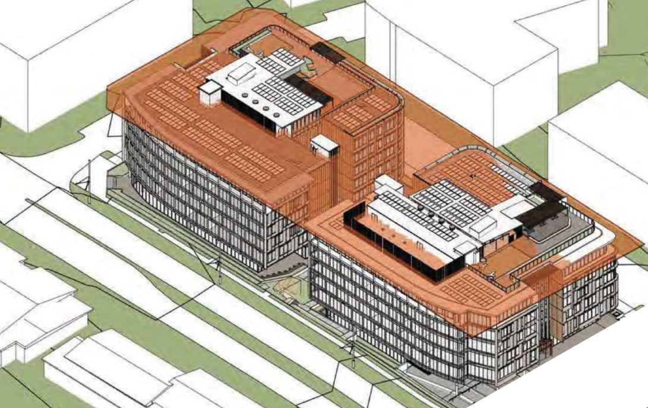
Figure 12: Height of building plane (24m) in relation to the proposed development, showing areas of contravention.

On 1 November 2023, amendments were made to the standard Section 4.6 relating to variations to development standards across all applicable environmental planning instruments. Pursuant to Section 2.45 State Environmental Planning Policy Amendment (Exceptions to Development Standards) 2023 (SEPP Amendment), a Development Application made but not yet determined before the commencement of the SEPP Amendment must be determined as if the policy had not commenced. As such, the DA will be assessed against the original Section 4.6 provisions.

Section 4.6(3) states that development consent must not be granted for a development that contravenes a development standard unless the consent authority has considered a written request from the applicant that seeks to justify the contravention of the development standard by demonstrating:

- the applicant’s written request has adequately addressed the matters required to be demonstrated by Appendix 2, Section 4.6(3) of the Precincts SEPP, and

- the development will be in the public interest because it is consistent with the objectives of the particular standard and the objectives for development within the zones in which the development is proposed to be carried out.

In accordance with Section 4.6(3), the applicant requests that the height of buildings development standard be contravened. The applicant’s written request is attached to this report which addresses why the compliance is unreasonable and unnecessary in the particular circumstances of the case and outlines the following key environmental planning grounds to justify contravening the development standard for the following reasons:

- The proposed building height and scale is consistent with the adopted long-term masterplan for the Town Centre endorsed under the DCP.

- The breach of the height limit does not have any environmental impacts on the surrounding Town Centre.

- The lift wells, condenser areas and skylights have been centrally located within the roof area to ensure they are not visible from the street level.

- Requiring strict compliance would not result in an enhanced urban design or environmental outcome.

Pursuant to clause 4.6(3) of the Western Parkland City SEPP, Council staff are satisfied that:

- The applicant’s written request has adequately addressed the matters required to be demonstrated by clause 4.6(3) of Western Parkland City SEPP (2021); and

- The development will be in the public interest because it is consistent with the objectives of the particular standard and the objectives for development within the zones in which the development is proposed to be carried out.

The development standard contravention is supported for the following reasons:

- The development is consistent with the objectives of the development standard:

- To preserve the amenity of adjoining development in terms of solar access to dwellings, private open space and bulk and scale.

The nearest residential dwelling to the proposed development is approximately 100m west being a block of attached dwellings presenting to South Circuit (see figure 13 below). Additionally, the site is envisaged to support a range of residential flat buildings which will be located to the north of the proposed development. There will be no overshadowing of residential areas or, areas where residential flat buildings are envisaged to be located. Given the above, the amenity of existing and future residential development located north of the site is not compromised as a result of the proposed height contravention.

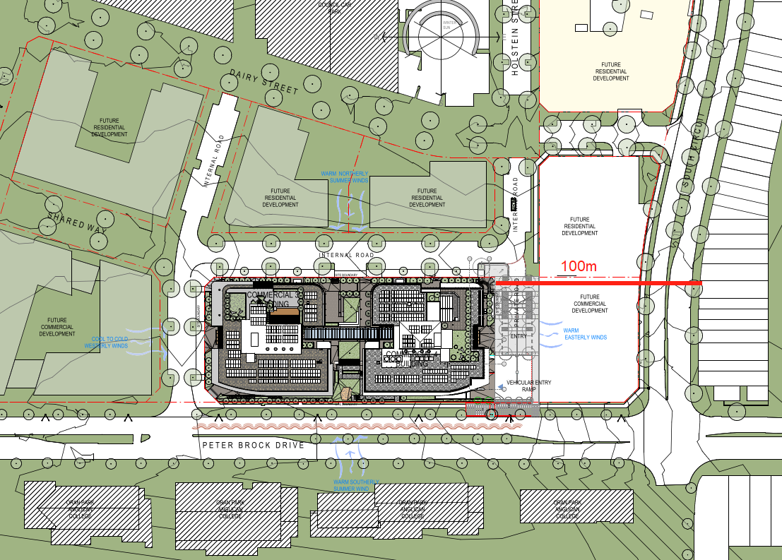
Figure 13: The development in relation to existing residential.

- To provide for a range of residential building heights in appropriate locations that provide a high quality urban form.

As shown by figure 13 above, the immediate surrounds are envisaged to accommodate residential flat buildings to the north-east, north and north-west. Of note, DA/2023/265/1 was recently approved, granting consent for the construction of two x seven storey residential flat buildings. Whilst the proposed development does not provide for any residential landuse, Commercial Buildings 3 and 4 have been located so as to ensure that residential development can be provided where north / south orientations can be maximised. The development has been further guided by Part B of the Oran Park DCP, which stipulates objectives and controls relating to height, bulk, scale and overall design. As such, the proposed development has been located appropriately and the height contravention is unlikely to impede on appropriate location of residential development or, impact on its urban form.

- To facilitate higher density neighbourhood and town centres while minimising impacts on adjacent residential areas.

The height contravention will facilitate additional commercial floor area within the town centre. Importantly, there is no commercial floor area proposed above the prescribed height limit, with the contravention limited to service areas, lift overrun and portions of the upper outdoor areas. The height contravention is considered to enable a commercial development in the town centre, one of which was envisaged for the site. The location and design of the buildings have taken into consideration overshadowing, whereby it has been demonstrated that overshadowing of existing residential areas is negligible.

- To provide appropriate height controls for commercial and industrial development.

The site is currently vacant and undeveloped however, it is envisaged that it will incorporate mixed landuses with varying heights (2–7 storeys) (see figure 14). Commercial Buildings 3 and 4 will establish a height of building which is generally consistent with the existing building heights observed across the town centre. The following contraventions relate to commercial developments within the town centre which exceed the maximum height of building development standard, figure 15 shows their location.

- DA/2017/1526/1 – Commercial Building 1 – 28.15m (17%).
- DA/2018/1223/1 – Podium Stage 1 – 28m (16%).
- DA/2019/269/1 – Commercial Building 2 – 28.85m (20.20%).
- DA/2023/263/1 – Podium stage 3b and six-storey hotel – 26.2m / 9.2%.

The contravention is necessary to support the lift over-run which provides access to the communal rooftop areas together with plant areas and equipment. Importantly, the contravention is limited centrally to both buildings. Hypothetically, if the standard was complied with, there would be minimal visible change when viewed from the public domain, as the building envelope effectively obscures the height contravention. The proposed height contravention is within the established heights of the town centre for commercial developments. As such, the proposed height is considered to be appropriate in respect of it developing context.

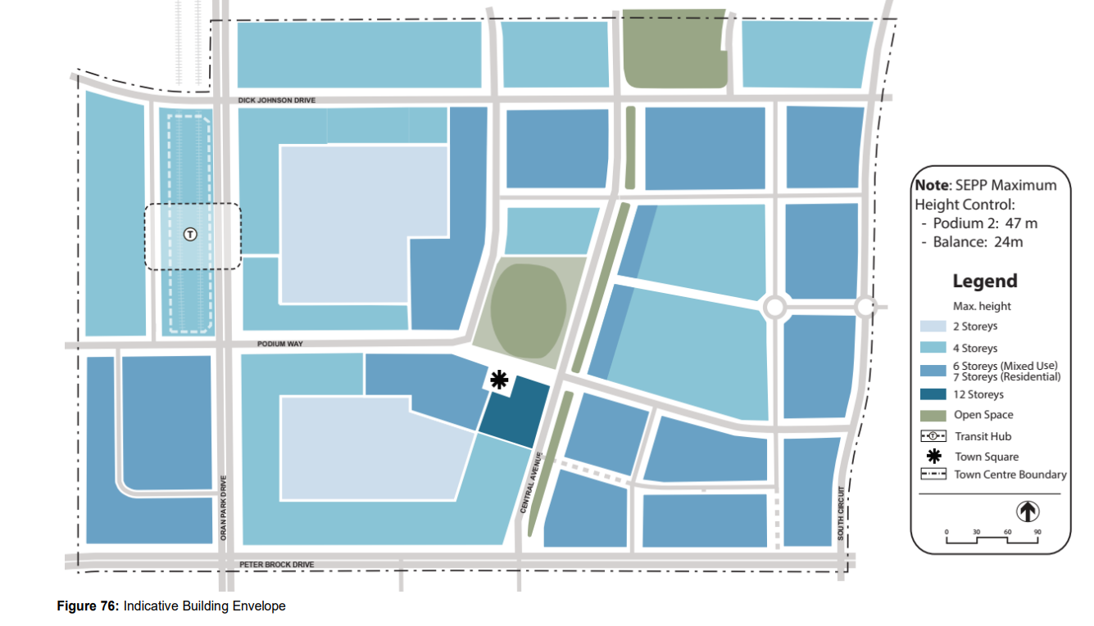
Figure 14: Number of storeys envisaged for the site (shown red outline).
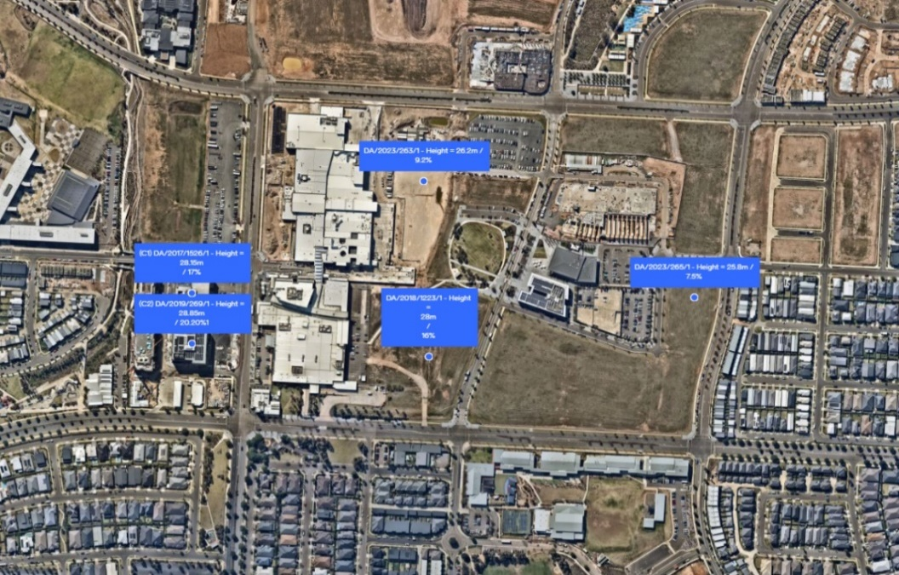

Figure 15: Showing height contraventions for commercial development within the town centre. Note: DA/2023/265/1 is a residential landuse but is shown for comparative purposes.
- The development is consistent with the objectives for development within the zones in which the development is proposed to be carried out:

- To provide a range of retail, business, entertainment and community uses which serve the needs of people who live in, work in and visit the local area.

Commercial Buildings 3 and 4 play an important role in contributing a significant amount of office space to the town centre. The office space generated as a result of the proposed development will assist in enabling a range of businesses to operate within the town centre, subsequently serving the needs of the people who work, live and visit the local area.

- To encourage employment opportunities in accessible locations.

Commercial Buildings 3 and 4 are located in accessible distances from existing residential areas to the east and south together with developing medium density residential areas north and west of the site. In addition, the site is highly accessible by vehicles, with the site being bound by Peter Brock Drive, a major sub-arterial road connecting the Town Centre with the broader Local Government Area.

- To maximise public transport patronage and encourage walking and cycling.

Public transport, walking and cycling are all encouraged through the placement and design of the proposed development. Broadly, the site is located approximately 500m from the future Oran Park Train Station to the west of the site. The future train station will be readily accessible via a series of pedestrian only links and sharepaths. More specifically, the proposed development provides secure bike parking and end of trip facilities. Ultimately, the proposed development has considered its role in the broader, long-term expansion of the town centre and maximised various modes of transport to and from the site, with a focus given to public transport, walkability and cycling.

- To ensure that residential development does not detract from the primary function of the centre being to provide for retail, business, entertainment and community uses.

This objective is not relevant as the development is for commercial purposes only.

- To ensure that residential development does not preclude the provision of active uses at street level.

This objective is not relevant as the development is for commercial purposes only.

- To provide for land uses of a higher order and density within the Local Centre Zone than are permitted within the Neighbourhood Centre Zone or the Mixed Use Zone.

A total of 22,060m² of gross floor area is proposed by Commercial Buildings 3 and 4. Coupled with the proposed development’s location, scale and height, the landuse is of a higher order and density than observed in adjoining neighbourhood centres or mixed-use zones. Given this, the proposed development would not undermine the function and role of commercial development in adjoining zones.

- To provide for residential development that contributes to the vitality of the local centre.

This objective is not relevant as the development is for commercial purposes only.

It is noted that the Panel may assume the concurrence of the Secretary pursuant to Planning Circular PS 20-002.

Consequently, it is recommended that the Panel support the proposed contravention to the height of buildings development standard prescribed under Western Parkland City SEPP 2021.

(a)(ii) the provisions of any proposed instrument that is or has been the subject of public consultation under this Act and that has been notified to the consent authority (unless the Secretary has notified the consent authority that the making of the proposed instrument has been deferred indefinitely or has not been approved).

Draft Environment State Environmental Planning Policy (Draft Environment SEPP)

The development is consistent with the Draft Environment SEPP in that there will be no detrimental impacts upon the Hawkesbury-Nepean River system as a result of it.

Draft Remediation of Land State Environmental Planning Policy (Draft Remediation of Land SEPP)

The development is consistent with the Draft Remediation of Land SEPP in that it is consistent with the Resilience and Hazards SEPP.

(a)(iii) the provisions of any development control plan

The development is subject to objectives and controls contained within:

- Camden Development Control Plan (DCP) 2019; and
- Oran Park Development Control Plan (DCP).

An assessment table in which the development is considered against both DCP’s is provided as an attachment to this report.

(a)(iiia) the provisions of any planning agreement that has been entered into under section 7.4, or any draft planning agreement that a developer has offered to enter into under section 7.4

The site is subject to the Oran Park Voluntary Planning Agreement (VPA). The proposed development is consistent with the VPA subject to a general condition of consent attached to this report.

(a)(iv) the regulations (to the extent that they prescribe matters for the purposes of this paragraph)

The Environmental Planning and Assessment Regulation, 2021 prescribes several matters that are addressed in the conditions attached to this report.

(b) the likely impacts of the development, including environmental impacts on both the natural and built environments, and social and economic impacts in the locality

Delivery of Perimeter Roads.

Council has recently determined a development application that permits the creation of six community title lots, construction of roads, landscaping and associated site works (DA/2023/631/1).

The proposed development relies on DA/2023/631/1 as it:
- Creates lot 4 to which the Commercial Buildings 3 and 4 will exist on.

- Creates lot 10 which will enable the private road to be maintained under the scheme.

- Establishes the northern and western road frontages together with associated street plantings and footpaths.

An extract of DA/2023/631/1 is provided in figure 16 below.

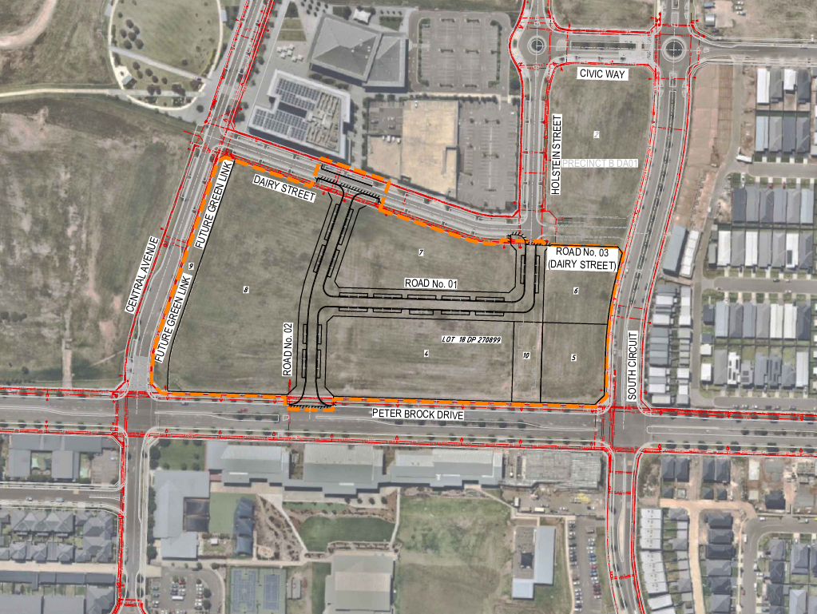
Figure 16: Approved DA/2023/631/1.

Shared Loading Dock, Basements and Private Road.

In order to enable the development to appropriately respond to each of its respective frontages, a shared loading dock and basement entry / exit via a private road has been proposed. The arrangement enables areas that would typically detract from the immediate streetscape to be consolidated to one frontage. This arrangement has enabled the development to create a pedestrian only through link between the two developments whilst creating a high-quality public domain around the southern, western and northern perimeter of the two buildings. To minimise any concern surrounding pedestrian / vehicular conflict that may exist, the following has been recommended by the applicants traffic engineer:

- A plan of management be developed and submitted as part of the construction certificate for the operation of the loading dock facility. The plan of management would include driver behaviour guidelines, approach vehicle communication requirements, hours of operation and pedestrian management during entering / exiting vehicle periods.

- The loading dock include provision of a flashing light system which is triggered by the opening of the roller door for all vehicles entering / exiting the loading dock to forewarn pedestrians that the loading dock is in use.

- Expanding pedestrian barriers are utilised during entering / exiting of vehicles at the loading dock should the dock manager not be available to manage pedestrians during these times.

Council staff are supportive of such recommendations and have recommended conditions of consent accordingly. The development is considered unlikely to have any unreasonable adverse impacts upon the natural and built environments or generate adverse social and economic impacts within the locality.

(d) any submissions made in accordance with this Act or the regulations

The DA was publicly exhibited for a period of 14 days in accordance with Camden Community Participation Plan 2021. The exhibition period was from 19 October to 2 November 2023 and no submissions were received.

(e) the public interest

The public interest is served through the detailed assessment of this DA under the Environmental Planning and Assessment Act, 1979, the Environmental Planning and Assessment Regulation, 2021, environmental planning instruments, development control plans and policies. Based on the above assessment, the development is consistent with the public interest.

External Referrals

External Referral | Response
Sydney Water. | Support with conditions attached to this report.
TfNSW | Comment provided for consideration.
Endeavour Energy | Comment provided for consideration.

Financial Implications

This matter has no direct financial implications for Council.

Conclusion

The DA has been assessed in accordance with Section 4.15(1) of the Environmental Planning and Assessment Act, 1979 and all relevant instruments, plans and policies. The DA is recommended for approval subject to the conditions attached to this report.

RECOMMENDED
That the Panel:

- Support the applicant’s written request lodged pursuant to Appendix 2, Section 4.6(3) of State Environmental Planning Policy (Precincts - Western Parkland City) 2021 to the contravention of the height of buildings development standard in Section 4.3 of the State Environmental Planning Policy (Precincts - Western Parkland City) 2021; and

- Approve DA/2023/556/1 for the staged construction of two six-storey commercial buildings and their use as an office premises comprising three levels of basement car parking and associated site works at 62 Central Avenue, Oran Park subject to the conditions attached to this report for the following reasons:

- The Panel has considered the written request to contravene State Environmental Planning Policy (Precincts - Western Parkland City) 2021 in relation to the height of buildings development standard. The Panel considers that the written request from the applicant adequately demonstrates that compliance with the development standard in Section 4.3 of State Environmental Planning Policy (Precincts - Western Parkland City) 2021 is unreasonable and unnecessary in the circumstances of the case, and that there are sufficient environmental planning grounds to justify contravening the development standard. The Panel is also satisfied that the development will be in the public interest because it is consistent with the objectives of the development standard in Section 4.3 of State Environmental Planning Policy (Precincts - Western Parkland City) 2021) and the land use objectives relating to the B2 Local Centre zone.

- The development is consistent with the objectives and controls of the applicable environmental planning instruments, being State Environmental Planning Policy (Precincts - Western Parkland City) 2021, State Environmental Planning Policy (Transport and Infrastructure) 2021, State Environmental Planning Policy (Resilience and Hazards) 2021, State Environmental Planning Policy (Industry and Employment) 2021 and State Environmental Planning Policy (Biodiversity and Conservation) 2021.

- The development is consistent with the objectives of the Oran Park Development Control Plan (as amended) and Camden Development Control Plan 2019.

- The development is considered to be of an appropriate scale and form for the site and the character of the locality.

- Subject to the recommended conditions, the development is unlikely to have any unreasonable adverse impacts on the natural or built environments.

- For the above reasons, the development is a suitable use of the site and its approval is in the public interest.

